JUnit Testing Exercises
Exercise 1: Setting Up JUnit Scenario: You need to set up JUnit in your Java project to start writing unit tests.
Steps:
1. Create a new Java project in your IDE (e.g., IntelliJ IDEA, Eclipse).
2. Add JUnit dependency to your project. If you are using Maven, add the following to your pom.xml: junit junit 4.13.2 test
3. Create a new test class in your project.

OUTPUT: 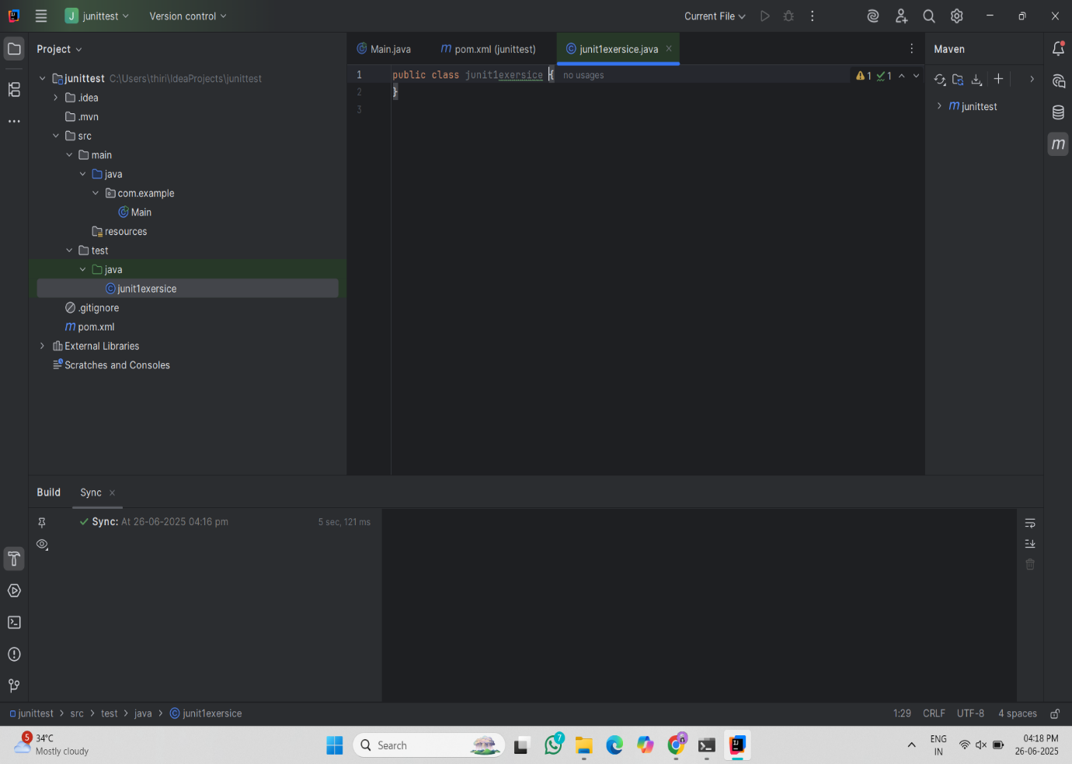

Exercise 2: Writing Basic JUnit Tests Scenario:
You need to write basic JUnit tests for a simple Java class.
Steps:
1. Create a new Java class with some methods to test.
2. Write JUnit tests for these methods.
SOLUTION:
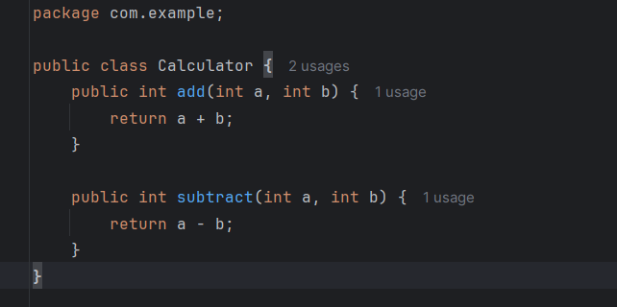
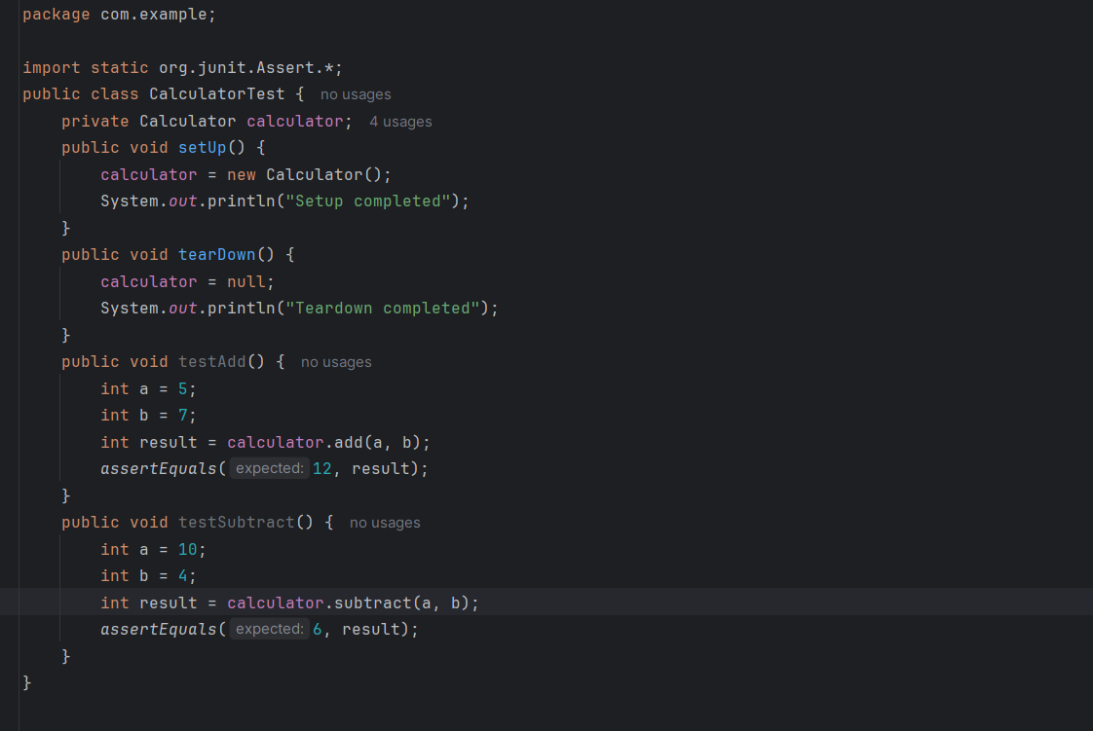
OUTPUT:
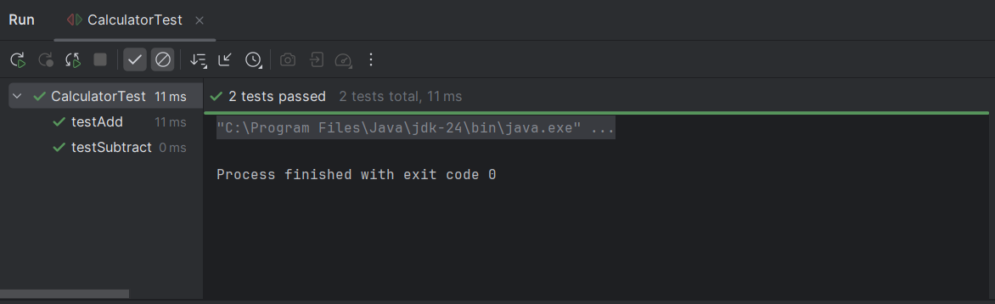

Exercise 3: Assertions in JUnit Scenario:
You need to use different assertions in JUnit to validate your test results.
Steps: 1. Write tests using various JUnit assertions.
Solution Code:
public class AssertionsTest {
@Test
public void testAssertions() {
// Assert equals
assertEquals(5, 2 + 3);
// Assert true
assertTrue(5 > 3);
// Assert false
assertFalse(5 < 3);
// Assert null
assertNull(null);
// Assert not null
assertNotNull(new Object());
}
}
SOLUTION:
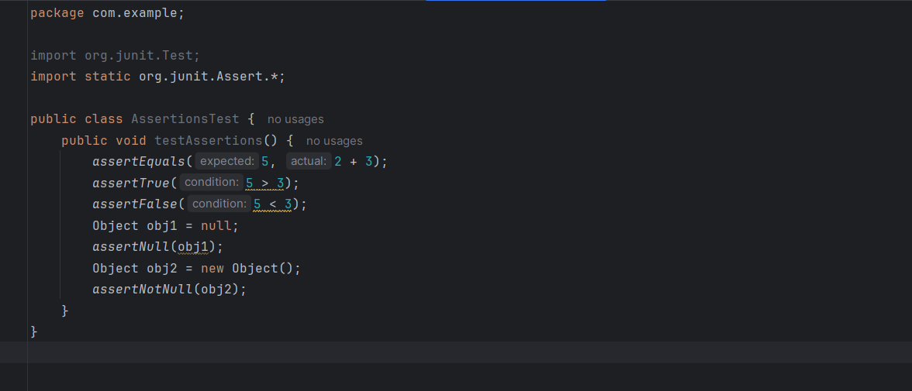

OUTPUT:

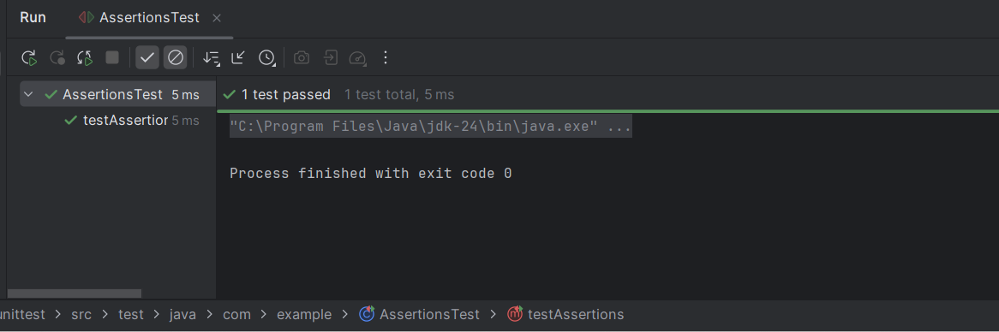

Exercise 4: Arrange-Act-Assert (AAA) Pattern, Test Fixtures, Setup and Teardown Methods in JUnit
Scenario:
You need to organize your tests using the Arrange-Act-Assert (AAA) pattern and use setup and teardown methods.
Steps: 1. Write tests using the AAA pattern.
2. Use @Before and @After annotations for setup and teardown methods.
SOLUTION:
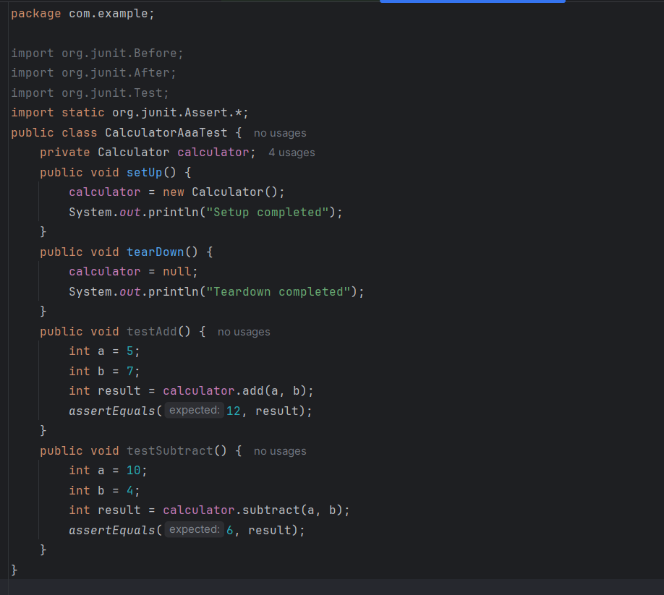
OUTPUT:
